LeeWayne Barrineau

9/26/2019

1. There are multiple entries for single field such as Titles field. An author could move thus also breaking the database.

2. The titles field is an example of a multivalued field.

3.

|  |  |  |  |  |  |  |
| --- | --- | --- | --- | --- | --- | --- |
| Author | Author Country | Book Title | Publishing Company | Publishing City | Copyright Year | Price |
| James Taylor | England | JavaScript Essentials | Tech Books | London | 2010 | $14 |
| James Taylor | England | HTML5 Exposed | Webby Books | London | 2012 | $15.50 |
| May Norton | United States | Big Data Big Promise | Data Press | San Francisco | 2012 | $25 |
| Jessica Lewis | United States | Database Development for the Cloud | Data Press | San Francisco | n/a | $20.35 |
| Jessica Lewis | United States | Data Services | Data Services | New York | n/a | $12.95 |

4. 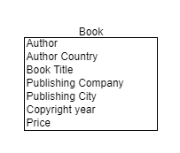

5. In the current entity there are two functional dependencies one being the author and the book itself. Inside the book there is another functional dependency being the publishing company.

6. The following the entity and some attributes for the database.

* + - Author
      * Possible Candidate key are the following
        + A surrogate key based on an abbreviation of the author’s name and current country
        + A natural key based on the Author’s name.
    - Book
      * Possible Candidate key are the following
        + A composite key based on the book’s name and published year
        + Also, a natural key based on the book’s name

7. 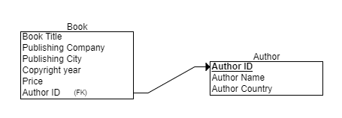

8. One transitive would be the publishing part of the book which would include publishing company, publishing location

9. 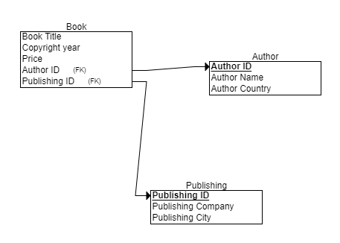

10. First, thing in the process to achieve the normal forms was to check to see if there were anything multivalued field. If there were any multivalued field, in this case there were being the titles field, split the field into as many new fields to hold the parts of the multivalued field. So, the titles field in the spreadsheet was split into the book title, publishing company, publishing city, copyright year and price. These new fields were then added back into the entity that held the multivalued field. Next, was to split any entities that held multiple different groups of attributes that had a sub theme or also called functional dependencies. This functional dependencies in the book collection entity were the portions of the author and part that pertains to the book. These subthemes were made into two entities being the author entity and book entity. Then these new entities were checked for any attribute that does not describe the current entity it is in, inside the book entity the publishing city, publishing company does not describe the book but the publishing company of the book. Thus, to hold these attributes a new entity called publishing company was created. This finally step created the third normal form for the book collection database.